Soil: The Wealth Beneath Your Feet
Background:
Unless you are a farmer or a gardener, you probably think of soil as “dirt”—as something you don’t want on your hands, clothes, or carpet. Yet your life, and the lives of most other organisms, depends on soil, especially topsoil. Soil is not only the basis of agricultural food production, but is essential for the production of many other plant products such as wood, paper, cotton, and medicines. In addition, soil helps purify the water we drink, and is important in the decomposition and recycling of biodegradable wastes.
Nations, including the United States, have been built on the riches of their soils. Yet since the beginnings of agriculture, people have abused this vital, potentially renewable resource: entire civilizations have collapsed because of mismanagement of the topsoil that supported their populations. Today, we are not only facing loss of soil from erosion, we are also depleting nutrients in some soils and adding toxins to others.
Soil Texture:
Through the process of weathering, mineral rocks are broken down over long periods of time into fine particles of clay (very fine particles less than 0.002 mm in diameter), silt (0.002-0.05 mm) and sand (0.5 to 1.0 mm). The relative amounts of the different sizes of particles control two very important properties of soil: its fertility and its ability to hold water (see Table 1).
Table 1: Relationship between soil component and various important properties of soil
Soil Component | Water Infiltration Capacity | Water Holding Capacity | Nutrient Holding Capacity | Aeration | Workability  (“Tilth”)
Clay | Poor | Good | Good | Poor | Poor
Silt | Medium | Medium | Medium | Medium | Medium
Sand | Excellent | Poor | Poor | Good | Good
Organic Matter | Good | Excellent | Excellent | Poor to Good | Poor to Good

Soil Fertility is measured by the amount of nutrients available for plant growth. These nutrients in soils are usually found in the form of positively charged ions such as Na⁺, H⁺, Ca⁺, or K⁺. Since the very small particles of clay (called micelles) often have a negative charge, these ions can be held in the soil on the surface of the micelles. The larger particles of silt and sand do not have this negative charge. Thus soils with more clay tend to be more fertile.
The infiltration (absorption) and retention of water in soil are also important. Soils with low infiltration, such as clay, are more likely to have high runoff after rain and the potential for flooding. Yet these soils can retain a good deal of water. In contrast, sandy soils have very high infiltration rates, but are unable to retain much water (most of the water continues to flow through the soil to the water table). High infiltration can result in leaching, the loss of nutrient ions from the layers of soil where roots are most abundant. These soils are more likely to be infertile, and the leachate can have high concentrations of nutrients and pesticides, polluting both the water table and adjacent rivers and lakes.
Thus, the “best” soils, called loam, are a mixture of sand, silt, and clay. These soils contain the best of each of the textural components, and have relatively high fertility and at the same time, relatively high water holding capacity.
Soil Organic Matter:
Organic matter is another very important component of soils. Not only is the organic matter the source of most nutrients (derived from the decomposition of dead plant and animal materials), but it, too, is composed of small, negatively charged micelles. Thus, like clay, organic matter in the soil is important in retaining nutrient ions. In addition, organic matter is excellent at absorbing and holding water in the soil. In some cases, the addition of organic matter can increase the water holding capacity of a soil 9-fold! Peat moss is an example of organic matter that can be added to soil.
Soil pH:
The acidity (pH) of a soil is another factor in determining the nutrient status of a soil. In general, more acid soils (lower pH) have lower fertility than more basic soils because the H⁺ ions in the acid displace the positively charged nutrient ions in the soil micelle. These nutrient ions can then be leached from the soil.
In this exercise, you will be either “constructing” your own soil or testing an unknown soil sample. Before you do so, you must learn how to test for the infiltration rate, the water-holding capacity, and the nutrient retention of each component of the soil. You will also test to determine the percentages of each soil component in a soil sample, and will determine the type of soil in your sample from the Soil Texture Triangle.
Procedure:
- Testing the Percolation Rate and the Water Holding Capacity of Soil Component
  - Using a graduated cylinder, measure out 125 mL each of silt/fine sand, sand, gravel. We will not be using clay because it has too slow of a percolation rate and too high of a water holding capacity. Fold a piece of filter paper so that it creates a cone. Place the cone into the cut off top of a drink bottle. Put this over a 250 mL beaker. Pour each sample of soil into the pop top, and compact sample by gently bouncing the pop top on the table.
  - Percolation rate: Fill a graduated cylinder with 50 mL of water. Starting with the silt/fine sand tube, pour about 25 mL of water into the tube in a steady stream, trying not to disrupt the soil surface.
  - Note the time when you start to pour and the volume of water poured. The stop time is when all the water has been absorbed from the surface of the soils and the water has reached the bottom of the tube, saturating the soil. If the surface water is almost gone and there is still dry material in the tube, add more water, estimating about how much will be needed to completely soak the material. Keep track of the total amount of water used.
  - Calculate the percolation rate as mL/min/area (remember the equation for the surface of a circle Circumference= 2πr, Area=πr²) Record in data table 1.
  - Repeat procedure for the sand and gravel tubes.
- Water Holding Capacity
  - Continue to add water to your samples (keep track of the total volume of water added, including the amount added in #2 above) until the sample is completely saturated and water begins to pool in the bottom of the beaker. Decant off any standing water from the sand tube and/or the silt tube by placing your hand over the opening and tilting the tube over the sink to allow excess water to run off.
  - Remove three samples (approximately 1 tablespoon each) from each tube and place sample in its own aluminum container or small piece of aluminum foil that has been folded on the sides to create a tray.
  - Weigh each of the three samples separately, and then place in a drying oven overnight.
  - After completely drying, weigh each sample again and calculate water holding capacity for each sample by using the following formula and record in data table 2.

Wet Mass – Dry mass x (100)
Dry Mass

- Determination of Soil Composition by Separation of Layers
  - Place approximately 25 mL of field soil in a 100 mL graduated cylinder. Make sure it is free of roots, stones, etc., and is well broken up.
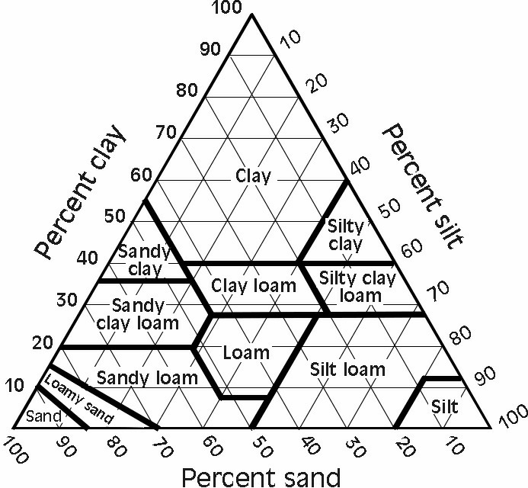
  - Add water to the 75 ML line
  - Cover the cylinder with parafilm, place the palm of your hand firmly over the opening, and invert the cylinder several times until the soil is thoroughly suspended in the water.
  - Place the cylinder on the lab bench and leave overnight.
  - When the soil has settled out, there should be three reasonably distinct layers—sand, silt, and clay. Measure the volume of each layer and the total volume of the sample.
  - Calculate the percent of each of the components. Be sure not to count the water.
- Determination of Soil Composition Using Soil Texture
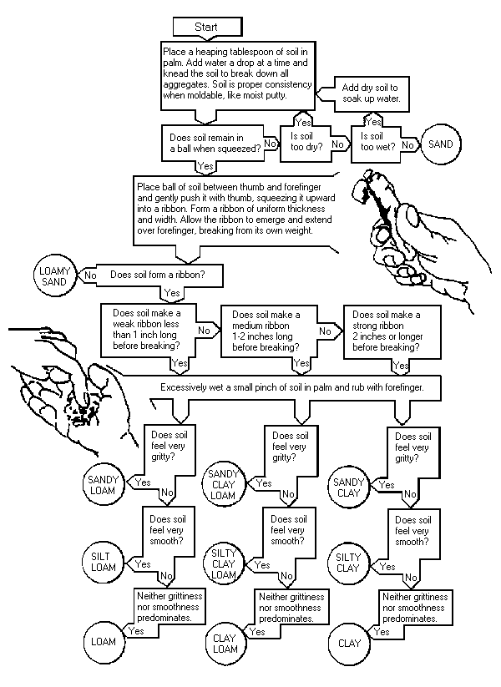
  - Use the following flow chart to determine the percent composition of field soil sample.

- Soil Horizons and Nutrient Testing
  - Observe the soil core samples laid out by your instructor. Using a ruler, measure the depth of the horizons in centimeters and record in your data table.
  - Using a sample from the A and B horizons use the nutrient test kits to determine nitrogen, pH, phosphorus, and potassium. You may work with another group and share data. Record your results in the data table.
DATA TABLE 1: Percolation Rates
Area of circle =
Percolation rate= mL/cm²/min
Particle Size | Water in mL | Start Time | End Time | Percolation Rate
Silt/fine sand
sand
gravel

DATA TABLE 2: Water Holding Capacity
Particle Size | Wet Mass | Dry Mass | Water Holding Capacity
Silt/fine sand
sand
gravel

DATA TABLE 3: Soil Horizons and Nutrient Comparison
Depth of O Horizon | Depth of A Horizon | Depth of B Horizon

Chemical Test | Horizon A | Horizon B
pH
Nitrogen
Phosphate
Potassium

DATA TABLE 4: Soil Composition
 | Sand | Silt | Clay
Measurement of Each Layer
Percent Composition of Each Layer

Soil Type Using Soil Triangle: ________________________________

Soil Type Using Flow Chart: __________________________________

Please read the lab background information before answering these questions.
- Complete the following data table:
Component | Percolation Rate | Water Holding Capacity
Fine Sand/Silt
Sand
Gravel

- Make a summary statement regarding the data presented in the table.

- Given the information in the soil texture triangle, and based on the knowledge you have developed about soil types and water in this lab, answer the following questions:
Which of the following soil types might you expect would support more vegetation—Sandy Loam or Silty Clay? Why? (Assume that for the best vegetation both too little and too much water are problems).

- If you were to test nutrient holding capacity in the three particle sizes, which would you expect to hold nutrients the best—sand, silt, or clay? What chemical characteristic causes these particles to bind to nutrients? Explain.

- If you were a farmer and wanted to increase water holding capacity, what might you add to the soil to amend it? If you soil is too acidic, what could you add to adjust the pH? (You might need to research this on the Internet).

- How deep was the A horizon in the soil sample you measured? If the rate of top soil for temperate deciduous forest (where this soil was sampled) is 1 inch/225 years, how long did it take for this horizon to develop?
Measurement in inches for A horizon = _________________________

Number of years to develop = _____________________________
- Which of the procedures in this lab demonstrated porosity? Explain using a definition of porosity in your explanation.

- Which of the procedures in this lab demonstrated permeability? Explain, including a definition of permeability in your explanation.

- List below the physical and chemcial tests used in this lab.
Physical Tests Chemical Tests

